**People Admin Guide**

**Reviewing Applications:**

Logging In:

* Go to the main CC sign-on page, <https://www.coloradocollege.edu/ssi>
* Click the purple “Employment Portal” button and enter your normal CC credentials
* On the next page, click “Manage My Searches”. You should see the following screen:

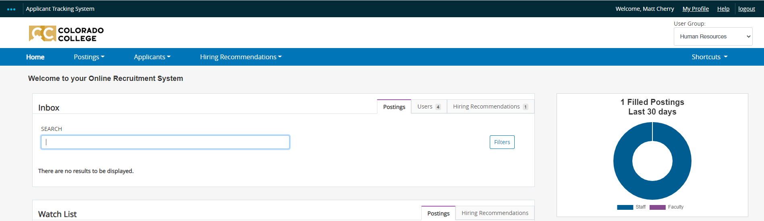

*If you do not see this screen and instead see the external job board, it is likely a cookie issue. Close your web browser (all windows, all tabs) and try logging back into the Employment Portal in a new session.*

**Reviewing Applications**

* Check your “User Group” in the top right corner. You may need to change it based on your role on the search team. CC uses the following groups:
  + Academic Staff – for Faculty searches only. This group has the ability to “disposition” faculty candidates (remove applications from consideration)
  + Supervisor/ Manager – for Staff searches only. This group has the ability to disposition staff candidates.
  + Search Team – used for both Faculty and Staff searches. This group can review applications, but cannot disposition candidates.
* Click on the “Postings” tab in the blue bar, and select either Faculty or Staff.

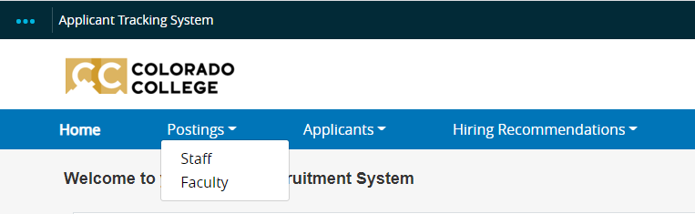

* When the page loads, you will see all postings you have access to in that user group.  
  *If you do not see your posting, check your user group in the drop-down menu in top right corner.*
* Click on the Job Title of the posting you wish to review applicants for.



* When the page loads, you will see the posting summary. Click the “Applicants” tab.  
  Graphical user interface, text, application

  Description automatically generated
* Once you click on the Applicants tab you will see a list of all the applicants for this position.

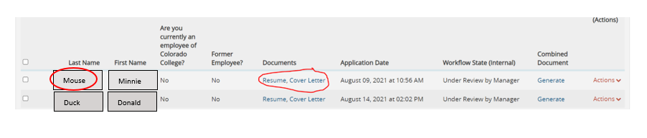

You can either click the last name for the full details on the applicant, or you can click the resume or cover letter link for a quick link to these documents.

**Dispositioning Applicants**

It Is very important to CC to have a positive applicant experience. To do this, we ask that you are timely in dispositioning your applicants. This means that you need to move them in the correct workflow. If you are not moving the applicant forward for an interview, you will need to move them into that workflow. Once the applicants are moved, they will receive an automated email thanking them for their interest in CC but we have moved forward with other candidates at this time. An applicant will not get sent the automated email if you select a workflow state that has “Contacted by Manager” in it.

To disposition applicants, you will need to go to your applicants tab, click on the check box by their name and then use the orange “Actions” button to click “move in workflow.”

After that, you will be given options on where to move them. Please use the most appropriate reasoning:

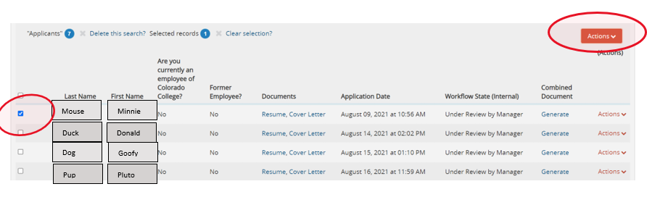



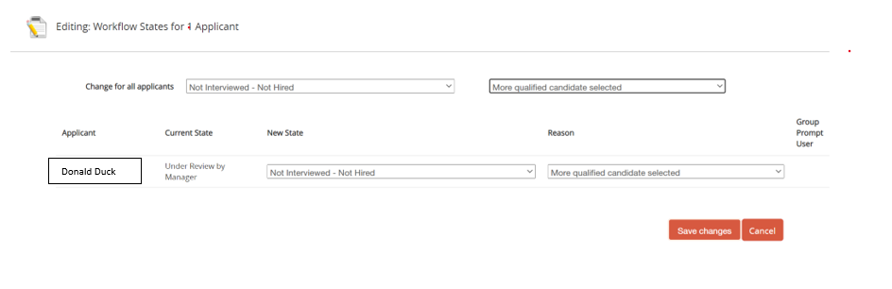

**Making a Hiring Recommendation**

Once you have narrowed down the applicant pool and have selected your top candidate, you must move the top candidate’s application to “Campus Interview Pending” state. You can do that by using the orange ‘Take Action on Job Application’ button and updating the status to Campus Interview Pending.

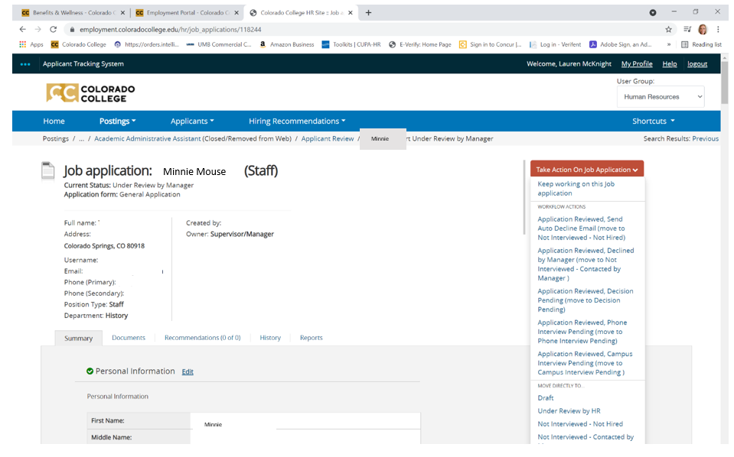

**Once the application is in Campus Interview Pending, you’ll see the Start Hiring Recommendation link in the top right-hand corner of the applicant’s application.**

To submit a hiring recommendation,

1.           Open your top candidate’s application (in the applicants tab) in PeopleAdmin, and click the “Start Hiring Recommendation” button on the right.

2.           On the next page, click the blue “Start Hiring Recommendation” button

3.           The Hiring Recommendation is a 3 page form:

a.           Page 1 – Recap of Search (which applicants were interviewed, and why this is the top candidate)

b.           Page 2 – Upload two/three phone reference check documents

c.           Page 3 – Summary of Pages 1 and 2

Page 3 will have its own orange “Take Action on Hiring Recommendation” button, similar to the screenshot above.  Once everything is complete, use that and select “Submit to HR.”

**\*The hiring recommendation needs to be completed with as much detail as possible. If HR still has questions after reviewing the recommendation, we may need contact you for more information which will prolong the hiring process. \***

HR will contact you once we have salary offer details. You will then be asked if you would like to make the offer or if you would like us to contact the candidate to offer the position and salary. Once an offer has been accepted, we will run a background check on the candidate. This could take up to 2 weeks but usually only takes a few days. Please allow at least 5 days after a background check has been completed before the candidate’s starts date.